Milestone 1: Define Problem / Problem Understanding

Activity 1: Specify the business problem Refer Project Description

Activity 2: Business requirements The business requirements for analyzing the performance and efficiency of Radisson Hotels include identifying KPIs, comparing performance across different hotels, identifying patterns and trends over time, identifying affecting factors, creating interactive dashboards and reports, identifying areas for improvement, making datadriven decisions, comparing to industry average and creating forecasting models for future performance. The ultimate goal is to gain insights and improve performance through data visualization techniques.

Activity 3: Literature Survey (Student Will Write) A literature survey is a method of researching existing literature and studies related to a specific topic. In the context of analyzing the performance and efficiency of Radisson Hotels, a literature survey would involve reviewing studies and articles that have been published on the topic of hotel performance and efficiency, as well as studies specific to Radisson Hotels.The literature survey would include sources such as academic journals, industry reports, and online articles. It would aim to identify key performance indicators (KPIs) and metrics that are commonly used to measure hotel performance and efficiency, as well as any best practices or strategies that have been identified for improving performance.The literature survey would also explore any existing research on Radisson Hotels specifically, and would aim to identify any unique challenges or opportunities that the hotel chain faces in terms of performance and efficiency

Activity 4: Social or Business Impact. Social Impact: Improve safety of customers & can get customer or guest satisfaction, and hygiene food. Business Model/Impact: By conducting an analysis the company can identify areas for improvement and take steps to enhance the customer experience, and increase customer satisfaction and loyalty.Improve its brand reputation, which can lead to increased customer loyalty and repeat business.

Milestone 2: Data Collection & Extraction from Database Data collection is the process of gathering and measuring information on variables of interest, in an established systematic fashion that enables one to answer stated research questions, test hypotheses, and evaluate outcomes and generate insights from the data.

Activity 1: Collect the dataset Please use the link to download the dataset: Link

Activity 1.1: Understand the data Data contains all the meta information regarding the columns described in the CSV files. we have provided 5 CSV files:

1. dim_date

2. dim_hotels

3. dim_rooms

4. fact_aggregated_bookings

5. fact_bookings Column Description for dim_date:

1. date: This column represents the dates present in May, June and July.

2. mmm yy: This column represents the date in the format of mmm yy (monthname year).

3. week no: This column represents the unique week number for that particular date.

4. day_type: This column represents whether the given day is Weekend or Weekday. Column Description for dim_hotels:

1. property_id: This column represents the Unique ID for each of the hotels

. 2. property_name: This column represents the name of each hotel.

3. category: This column determines which class[Luxury, Business] a particular hotel/property belongs to.

4. city: This column represents where the particular hotel/property resides in. Column Description for dim_rooms:

1. room_id: This column represents the type of room[RT1, RT2, RT3, RT4] in a hotel.

2. room_class: This column represents to which class[Standard, Elite, Premium, Presidential] particular room type belongs. Column Description for fact_aggregated_bookings:

1. property_id: This column represents the Unique ID for each of the hotels.

2. check_in_date: This column represents all the check_in_dates of the customers.

3. room_category: This column represents the type of room[RT1, RT2, RT3, RT4] in a hotel.

4. successful_bookings: This column represents all the successful room bookings that happen for a particular room type in that hotel on that particular date.

5. capacity: This column represents the maximum count of rooms available for a particular room type in that hotel on that particular date. Column Description for fact_bookings:

1. booking_id: This column represents the Unique Booking ID for each customer when they booked their rooms.

2. property_id: This column represents the Unique ID for each of the hotels

3. booking_date: This column represents the date on which the customer booked their rooms.

4. check_in_date: This column represents the date on which the customer checkin(entered) at the hotel.

5. check_out_date: This column represents the date on which the customer checkout(left) of the hotel.

6. no_guests: This column represents the number of guests who stayed in a particular room in that hotel.

7. room_category: This column represents the type of room[RT1, RT2, RT3, RT4] in a hotel.

8. booking_platform: This column represents in which way the customer booked his room.

9. ratings_given: This column represents the ratings given by the customer for hotel services.

10. booking_status: This column represents whether the customer cancelled his booking[Cancelled], successfully stayed in the hotel[Checked Out] or booked his room but not stayed in the hotel[No show].

11. revenue_generated: This column represents the amount of money generated by the hotel from a particular customer.

12. revenue_realized: This column represents the final amount of money that goes to the hotel based on booking status. If the booking status is cancelled, then 40% of the revenue generated is deducted and the remaining is refunded to the customer. If the booking status is Checked Out/No show, then full revenue generated will go to hotels.

Activity 2: Storing Data in DB & Perform SQL Operations Explanation video link:

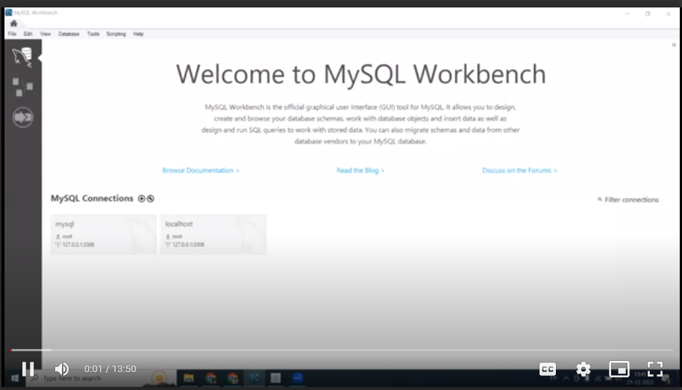

Activity 3: Connect DB with Tableau Explanation video link

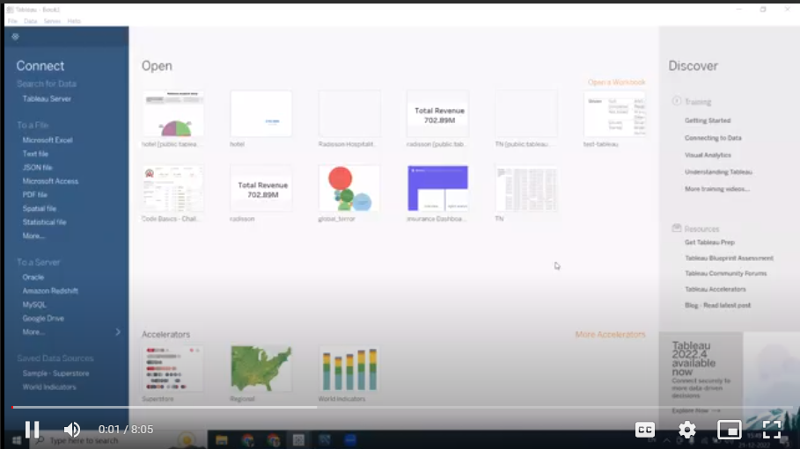

Milestone 3: Data Preparation

Activity 1: Prepare the Data for Visualization Preparing the data for visualization involves cleaning the data to remove irrelevant or missing data, transforming the data into a format that can be easily visualized, exploring the data to identify patterns and trends, filtering the data to focus on specific subsets of data, preparing the data for visualization software, and ensuring the data is accurate and complete. This process helps to make the data easily understandable and ready for creating visualizations to gain insights into the performance and efficiency.

Explanation video link 1: <https://drive.google.com/file/d/1SRA3ZmvxodiJSLgAFZaOIDdXSHxxyId4/view?usp=sharing>

Explanation video link 2:

<https://drive.google.com/file/d/1mXhs6GQLifchb1fxmnfe4hPhOwNKJkDB/view?usp=sharing>

Milestone 4: Data Visualization Data visualization is the process of creating graphical representations of data in order to help people understand and explore the information. The goal of data visualization is to make complex data sets more accessible, intuitive, and easier to interpret. By using visual elements such as charts, graphs, and maps, data visualizations can help people quickly identify patterns, trends, and outliers in the data.

Activity 1: No of Unique Visualizations The number of unique visualizations that can be created with a given dataset. Some common types of visualizations that can be used to analyze the performance and efficiency of Radisson Hotels include bar charts, line charts, heat maps, scatter plots, pie charts,Maps etc. These visualizations can be used to compare performance, track changes over time, show distribution, and relationships between variables, breakdown of revenue and customer demographics, workload, resource allocation and location of hotels.

Activity 1.1: Revenue split by city Explanation video link:

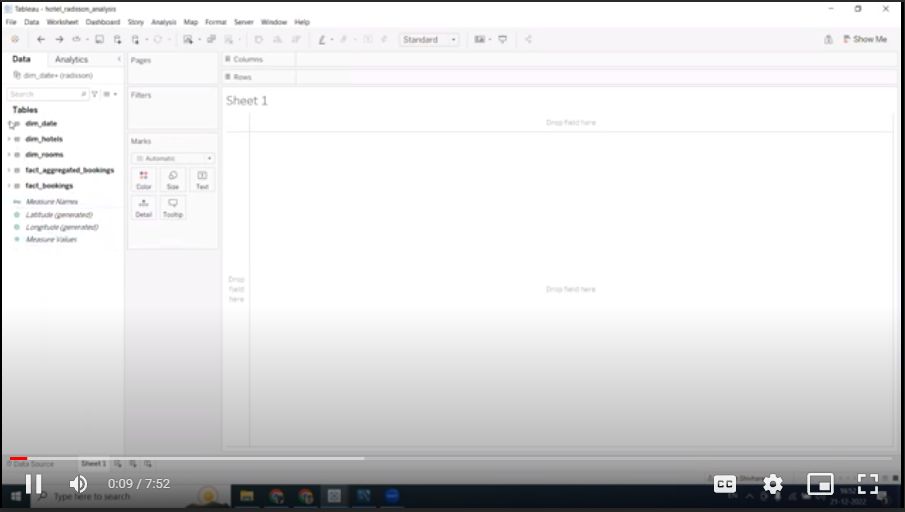

Activity 1.2: Occupancy split by city Explanation video link:

https://drive.google.com/file/d/1x8jWvHBIbY0VfuCEOVOwJc9xQP3lbivr/view?usp=sharing

Activity 1.3: Occupancy by day type Explanation video link:

https://drive.google.com/file/d/1fuLiuuxGVWIzdKwp1J2IJlhhLcWFPrB8/view?usp=sharing

Activity 1.4: Revenue by room class Explanation video link:

<https://drive.google.com/file/d/1nNOyxxQ_00N4FtgH4URw0dPcmdxYV2f/view?usp=sharing>

Activity 1.5: Booking % by platform Explanation video link:

https://drive.google.com/file/d/1HtTufhJIYoK3FmJcP1zJMgfg_3cjmmTU/view?us p=sharing

Activity 1.6: Property By key metrics Explanation video link:

https://drive.google.com/file/d/1wffXX8oyETBxcBzNWzVsFoa932- AjSJH/view?usp=sharing

Activity 1.7: Revenue contribution % by category Explanation video link: https://drive.google.com/file/d/1PXGL8mf3s4GjLTe3NgDB6RqsDS0Wu1Yv/view?usp =sharing

Activity 1.8: Successful Bookings by city Explanation video link: https://drive.google.com/file/d/1KDXNvhgXs1mQAoYNsSMEzMFlVGBquHZ- /view?usp=sharing

Activity 1.9: Successful Booking by date wise Explanation video link:

<https://drive.google.com/file/d/1Xkl1Ddiv3FYoFMtDbEwapOTFzfhWgg4/view?usp=sharing>

Activity 1.10: Total Revenue for the hotels Explanation video link:

https://drive.google.com/file/d/1GAhDNYv3USGAo_hYl_TyUi2AEjSY_M5y/view?usp =sharing

Activity 1.11: Total Successful Bookings Explanation video link:

<https://drive.google.com/file/d/16MQNTPXJnYdTWGNm_AKAvpvV1DEsMqA/view?usp=sharing>

Activity 1.12: Occupancy in % Explanation video link:

https://drive.google.com/file/d/15Mnm6kAPF7XGngonlfoUsqM_MYXTDAYk/view?usp =sharing

https://drive.google.com/file/d/1_x87vQWpYBaaHeuqAuSZLRn68yY3IY6C/view?usp =sharing

Milestone 5: Dashboard A dashboard is a graphical user interface (GUI) that displays information and data in an organized, easy-to-read format. Dashboards are often used to provide real-time monitoring and analysis of data, and are typically designed for a specific purpose or use case. Dashboards can be used in a variety of settings, such as business, finance, manufacturing, healthcare, and many other industries. They can be used to track key performance indicators (KPIs), monitor performance metrics, and display data in the form of charts, graphs, and tables.

Activity :1- Responsive and Design of Dashboard The responsiveness and design of a dashboard for analyzing the performance and efficiency of Radisson Hotels is crucial to ensure that the information is easily understandable and actionable. Key considerations for designing a responsive and effective dashboard include user-centered design, clear and concise information, interactivity, data-driven approach, accessibility, customization, and security. The goal is to create a dashboard that is user-friendly, interactive, and data-driven, providing actionable insights to improve the performance and efficiency of Radisson Hotels. Once you have created views on different sheets in Tableau, you can pull them into a dashboard.

Explanation video link:

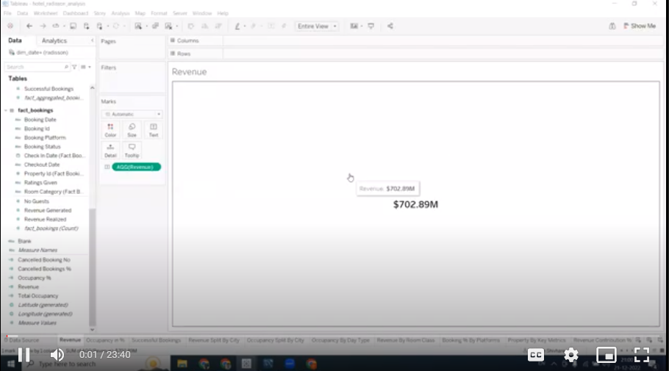

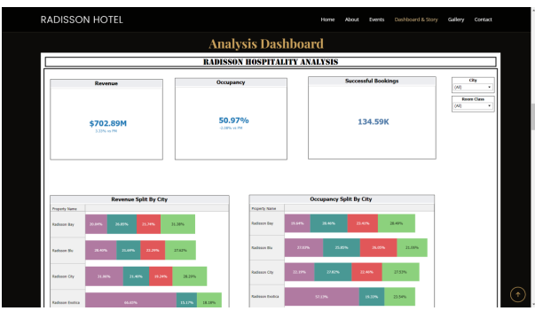

Milestone 6: Story A data story is a way of presenting data and analysis in a narrative format, with the goal of making the information more engaging and easier to understand. A data story typically includes a clear introduction that sets the stage and explains the context for the data, a body that presents the data and analysis in a logical and systematic way, and a conclusion that summarizes the key findings and highlights their implications. Data stories can be told using a variety of mediums, such as reports, presentations, interactive visualizations, and videos.

Activity:1- No of Scenes of Story The number of scenes in a storyboard for a data visualization analysis of the performance and efficiency of Radisson Hotels will depend on the complexity of the analysis and the specific insights that are trying to be conveyed. A storyboard is a visual representation of the data analysis process and it breaks down the analysis into a series of steps or scenes. Explanation video link:

https://drive.google.com/file/d/157OiKqBQiJWdMVpgiEKeN_SpVgcyLqhF/view?usp= sharing

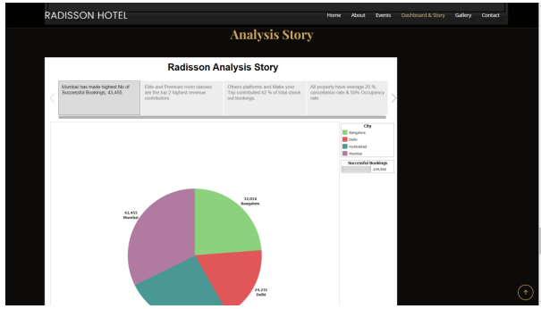

Milestone 7: Performance Testing

Activity 1: Amount of Data Rendered to DB

● The amount of data that is rendered to a database depends on the size of the dataset and the capacity of the database to store and retrieve data.

● Open the MySQL Workbench, go to the database then click to expand the tables,select the table and click on (i) button to get the information related to table such as column count,table rows etc.

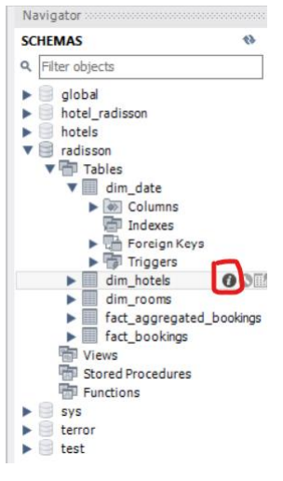

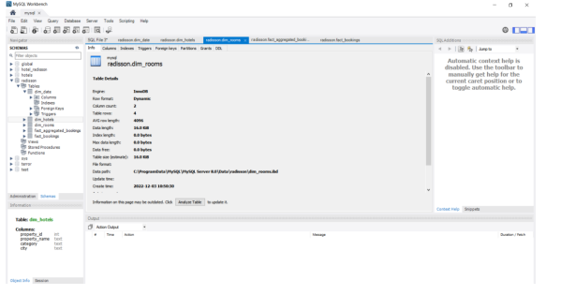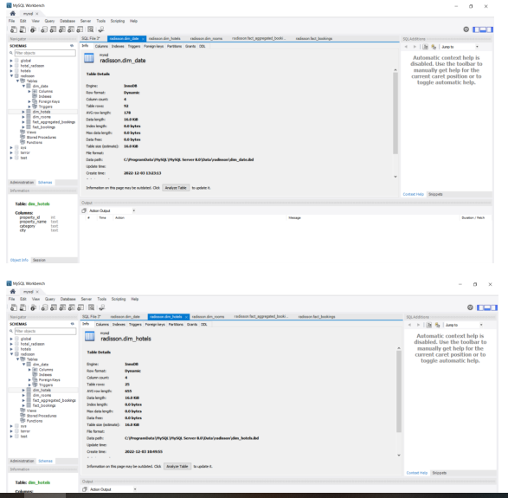

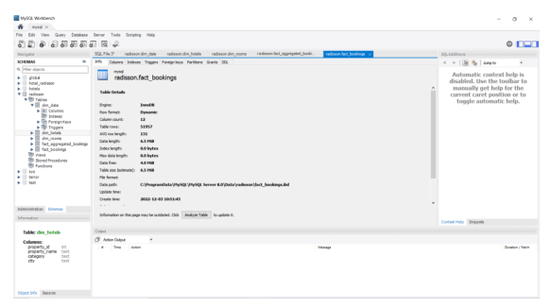

Activity 2: Utilization of Data Filters

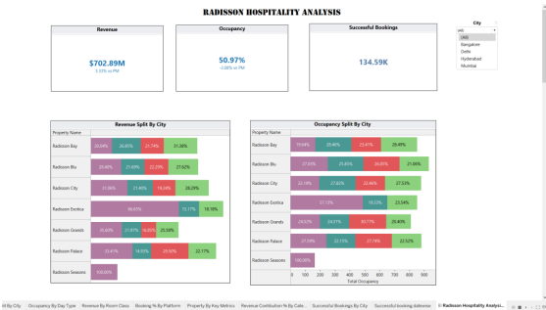

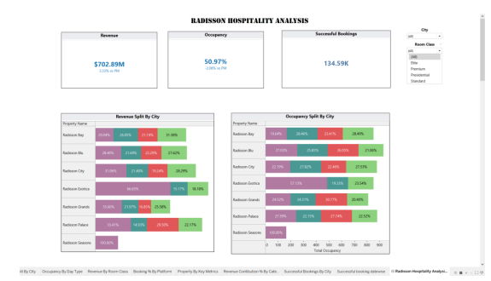

Activity 3: No of Calculation Fields

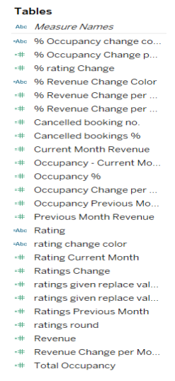

Activity 4: No of Visualizations/ Graphs

1. Revenue split by city

2. Occupancy split by city

3. Occupancy by day type

4. Revenue by room class

5. Booking % by platform

6. Property By key metrics

7. Revenue contribution % by category

8. Successful Bookings by city

9. Successful Booking by date wise

10. Total Revenue for the hotels

11. Total Successful Bookings

12. Occupancy in %

Milestone 8: Web integration Publishing helps us to track and monitor key performance metrics, to communicate results and progress. help a publisher stay informed, make better decisions, and communicate their performance to others. Publishing dashboard and reports to tableau public

Step 1: Go to Dashboard/story, click on share button on the top ribbon Give the server address of your tableau public account and click on connect. Explanation Video:- <https://drive.google.com/file/d/1AKAk2hiVyqS3td148uHbxr-Nk-k0uxET/view?usp=sharing>

Step 2: Once you click on connect it will ask you for tableau public user name and password Once you login into your tableau public using the credentials, the particular visualization will be published into tableau public Note: While publishing the visualization to the public, the respective sheet will get published when you click on share option.

Activity 1: Dashboard and Story embed with UI With Flask Explanation video link: https://drive.google.com/file/d/1UCDtmXj8FI4bgHeNZs2EZFYuJzVF_gwN/view? usp=sharing

Milestone 9: Project Demonstration & Documentation Below mentioned deliverables to be submitted along with other deliverables

Activity 1:- Record explanation Video for project end to end solution

Activity 2:- Project Documentation-Step by step project development procedure Create document as per the template provided